# Lab: CSS Presentation and Positioning

Problems for exercises and homework for the “HTML and CSS” course @ SoftUni. Submit your solutions in the SoftUni judge system at <https://judge.softuni.bg/Contests/406/Lab-CSS-Presentation-and-Positioning>.

## Briard History

Create a Web Page like the following.

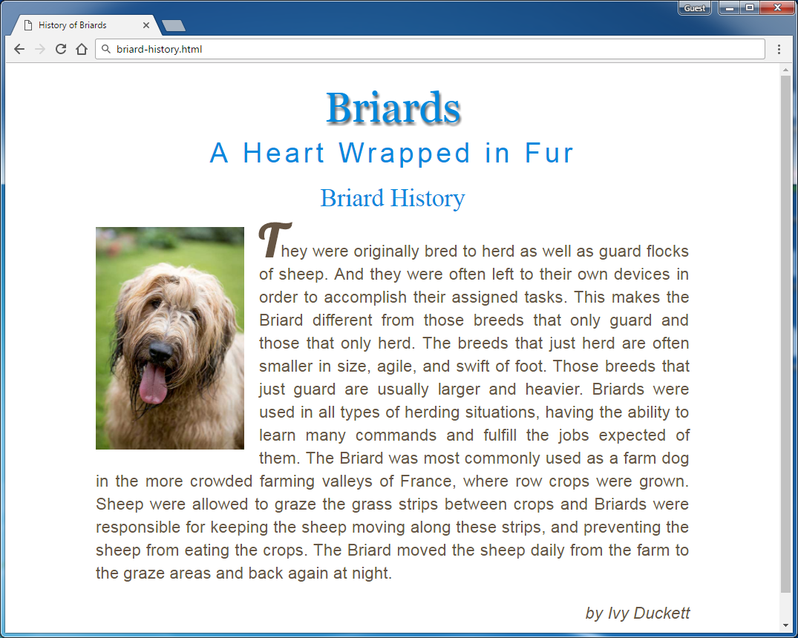

Create files: "**briard-history.css**" and "**briard-history.html**"

### Steps to Follow

Start with the **site header**:

* Copy the CSS @import for the ‘**Lobster**’ **font** from Google Fonts: [**https://fonts.googleapis.com/css?family=Lobster**](https://fonts.googleapis.com/css?family=Lobster)
* <html>
  + Text size: 16px;
* Main site
  + Center the main
  + Width: 800px;
  + Padding: 20px;
* Format the image: <img>
  + Width 200px
  + Float: Left
  + Margin-right: 20px

Test the site in the browser:

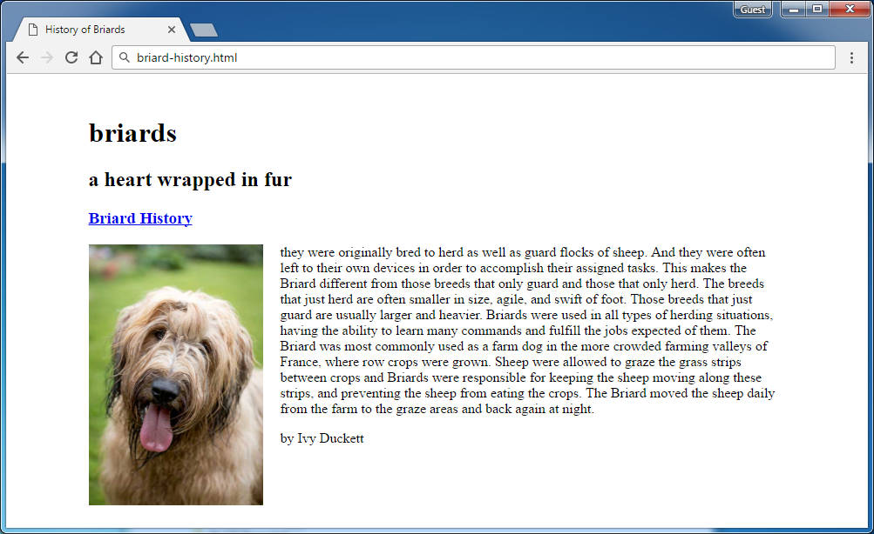

Now style the all headings and the hyperlink:

* <h1>,<h2>,<h3>,a
  + Font Style: **Normal**
  + Text color: **#0088dd;**
  + Margin: **0**
  + Center the text
  + Text Size: **2.1rem**
  + Remove **underline**
* **<h1>**
  + Font Family: **Georgia,Times,serif**
  + Text Size: **3.5rem**
  + Shadow for Text: **2px 4px 4px #666666**
  + Padding at the bottom: **10px**
  + Transform the text
* **<h2>**
  + Font Family: **Arial,sans-serif**
  + Text Size: **2.3rem**
  + Transform the text
  + Spacing between letter: **0.3rem**
* **<h2> <span>**
  + Transform the text to **none**

Test the site in the browser:

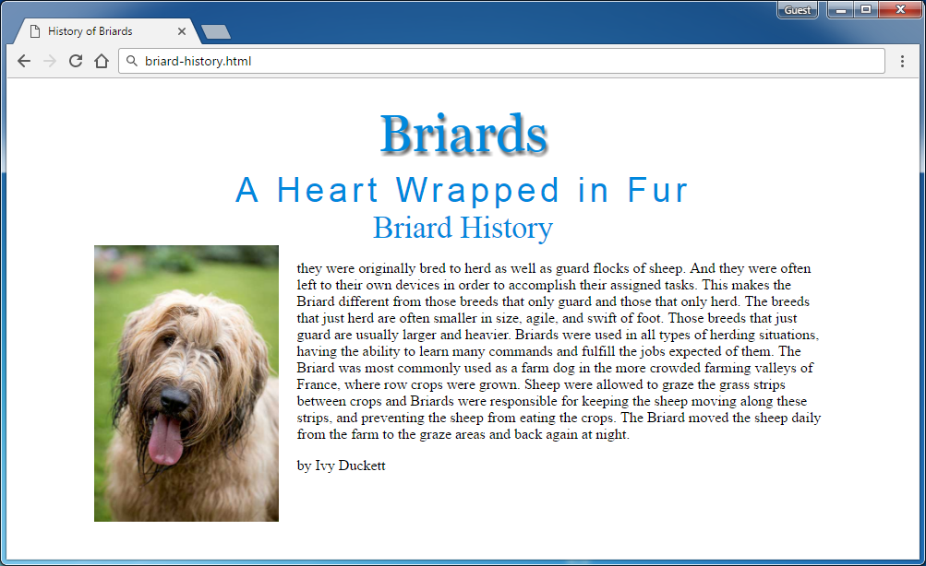

Now style the site content (article):

* **Article**
  + Margin at the top: **20px**
  + Align Text: **Justify**
* **Paragraphs in the article**
  + Font Family: **Arial,Verdana,sans-serif**
  + Text Size: **1.4rem**
  + Line Height: **30px**
  + Text Color: **#665544**
* **<p> for site author**
  + Text Style: **Italic**
  + Align the text to the **right**
* **First letter in the first article’s paragraph**
  + Text Site: **3.8rem**
  + **Font Family: 'Lobster',cursive**
  + Text Style: **bold**
  + Make the text **UPPERCASE**
  + **Hint**: use the pseudo-selector :first-of-type:first-letter

**Test** the site

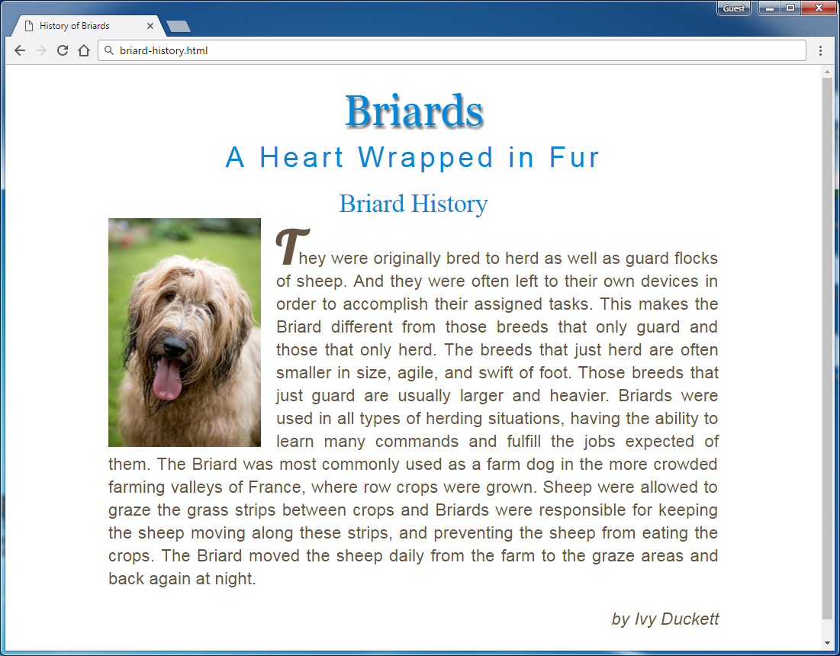

Now the site is styled completely. **Submit** your solution in the **SoftUni judge**:

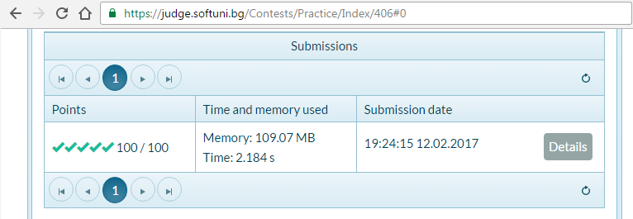

## Social Media

Create a Web Page like the following.

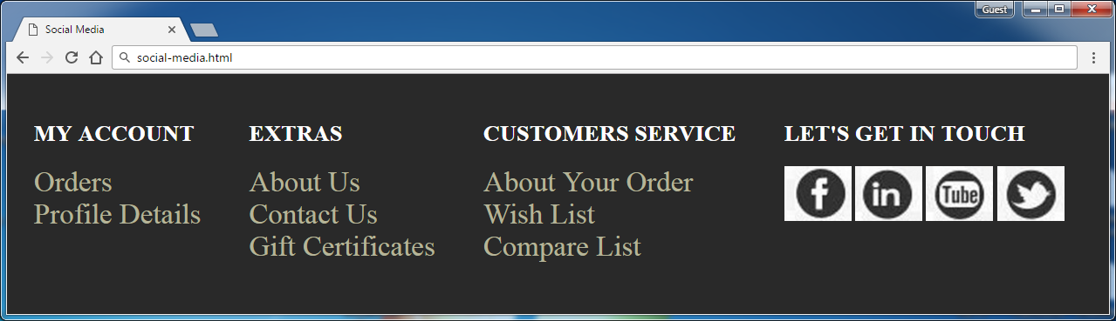 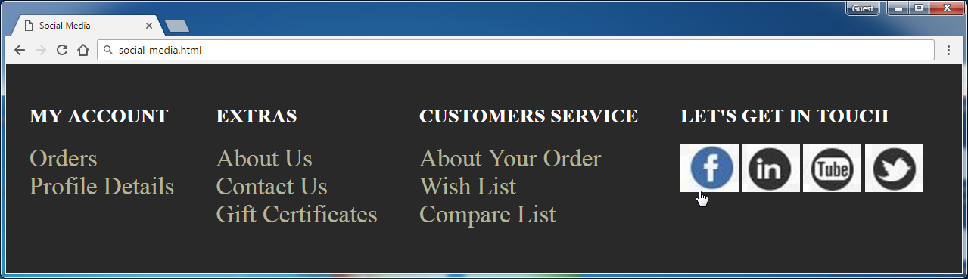

Create files: "**social-media.css**" and "**social-media.html**"

### Constrains

Use **Semantic tags**

## Drop Down Menu

Create a Web Page like the following.

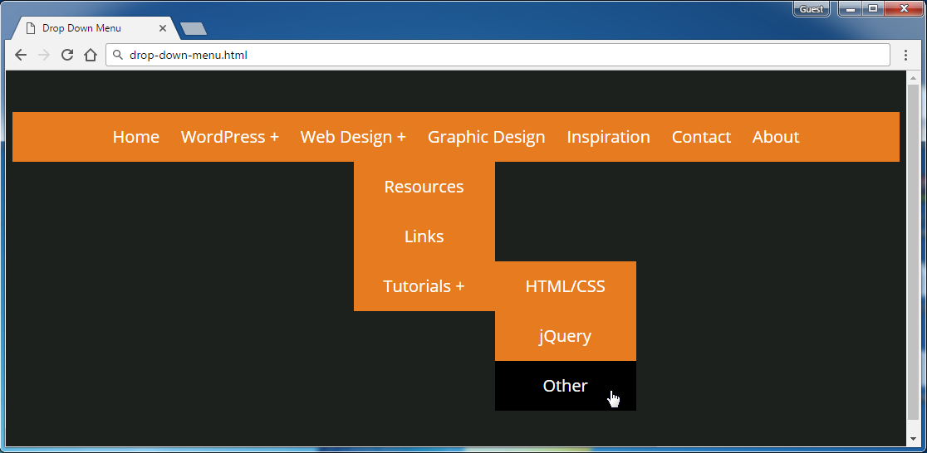

Create files: "**drop-down-menu**" and "**drop-down-menu.html**"

Default font: **"Open Sans", sans-serif**

[**http://fonts.googleapis.com/css?family=Open+Sans**](http://fonts.googleapis.com/css?family=Open+Sans)

Text Color: **#ffffff**

Background Color: **#1d211e, #e67c1f**

### Constrains

* Default font-size: **22px**

## Floating Elements

Create a Web Page like the following.

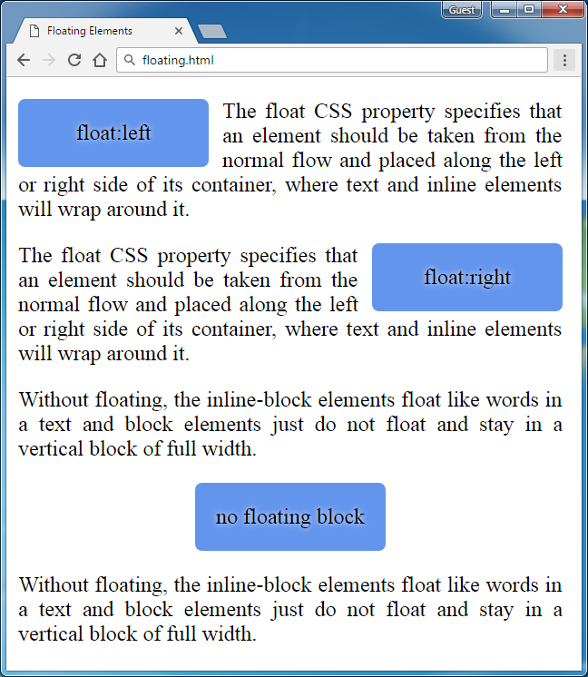

Create files: "**floating-elements.css**" and "**floating-elements.html**"

Use **Semantic tags**

### Constrains

Use **Divs** with class **left, center and right** to display the floated elements.

**Paragraphs** for text

## Clear Floating

Create a Web Page like the following.

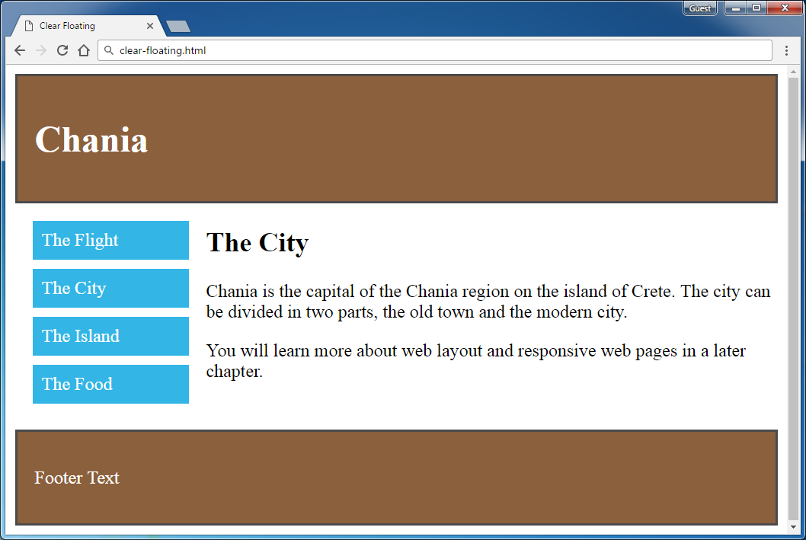

Create files: "**clear-floating.css**" and "**clear-floating.html**"

Use **Semantic tags**

### Constrains

Use **float left** and **float right** + **clear the float**

Use **Main** with class **clearfix**